**MIN PROJECT**

(2020-2021)

**IOT based Fire Fighting Robot**

**MID-TERM REPORT**



**Institute of Engineering & Technology**

**Department of Computer Engineering & Application**

**Team Members**

NITISH KUMAR

(181500437)

VIKAS YADAV

(181500791)

RANJAN KUMAR

(181500557)

**Supervised By**

Mr. Mandeep Singh (Technical trainer)

**DEPARTMENT OF COMPUTER ENGINEERING AND APPLICATIONS, GLA UNIVERSITY, MATHURA**

**Contents**

1. Acknowledgment

2. Introduction

2.1 Motivation and overview

2.2 Objective

2.3 Scope

3. Component

4. Working model and result analysis

5. Pin Diagram

6.Problems

7. Layout

8.Conclusion

9. References

**Chapter 1**

**ACKNOWLEDGEMENT**

We have taken efforts in this project. However, it would not have been possible without the kind support and help of many individuals. On the completion of this project, I would like to extend my sincere thanks to all of them. I am highly indebted to this project guide **Mr Mandeep Singh** , **Technical trainer** for their guidance and constant supervision as well as for providing necessary information regarding the project. I wish to extend my sincere gratitude to **Prof. Anand Singh Jalal, Head ofDepartment of Computer Engineering and Applications** and faculty of CEA Department of **GLA University** for their guidance, encouragement and give this opportunity and valuable suggestion which prove extremely useful and helpful in completion of this project. I would also like to thank all those who directly or indirectly supported or helped me. I would like to express my gratitude towards my parents and member of my college for their kind cooperation and encouragement which helped me in completion of this project. All of them have willingly helped me out with their abilities.

**Chapter 2**

**INTRODUCTION**

**2.1Motivation and Overview**

Internet of Things is a field of technology that describes the network of various “things” that is physical objects that are all embedded with different sensors, that are destined to measure various things or parameters such as distance and presence of flame. It also has the ability to transfer over a network using technologies like Cloud computing and fog computing. Now days firing activity are much unpredictable and very difficult to control so, this type of iot based robot can make thing easy.

* 1. **Objective**

The fire fighting Robot is an intelligent safety management and monitoring system. The basic objective of this project is made to develop a system model. It monitors and keep a look over the place in which it is installed using sensors.

* 1. **Scope**
* Design a fire fighting robot using numerical approach.
* Select the suitable material to develop the robot.
* The developing of programming is necessary to develop a mechanism of the robot.

**Chapter 3**

**Component:-**

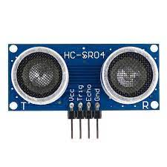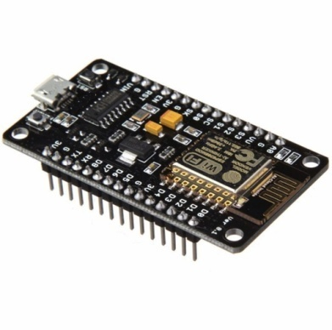Node mcu esp8266 Ultrasonic sensor

Flame sensorServo motor

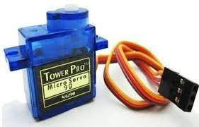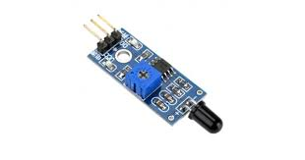

Mini water pump Bo motor

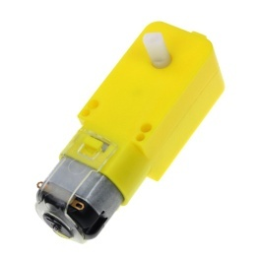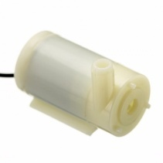

L293d motor driver

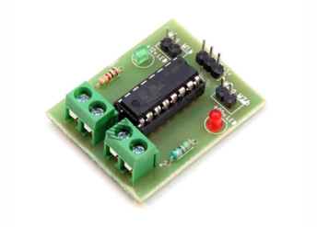

**Chapter 4**

**Working model and result analysis**

**ALGORITHM**

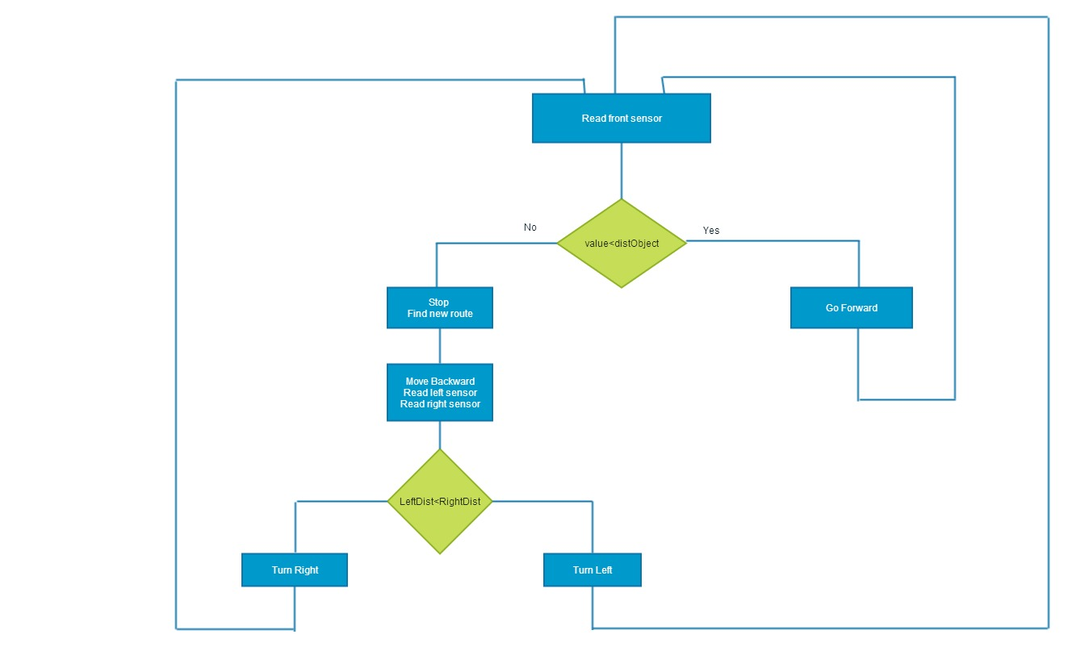

**Pin Diagram**

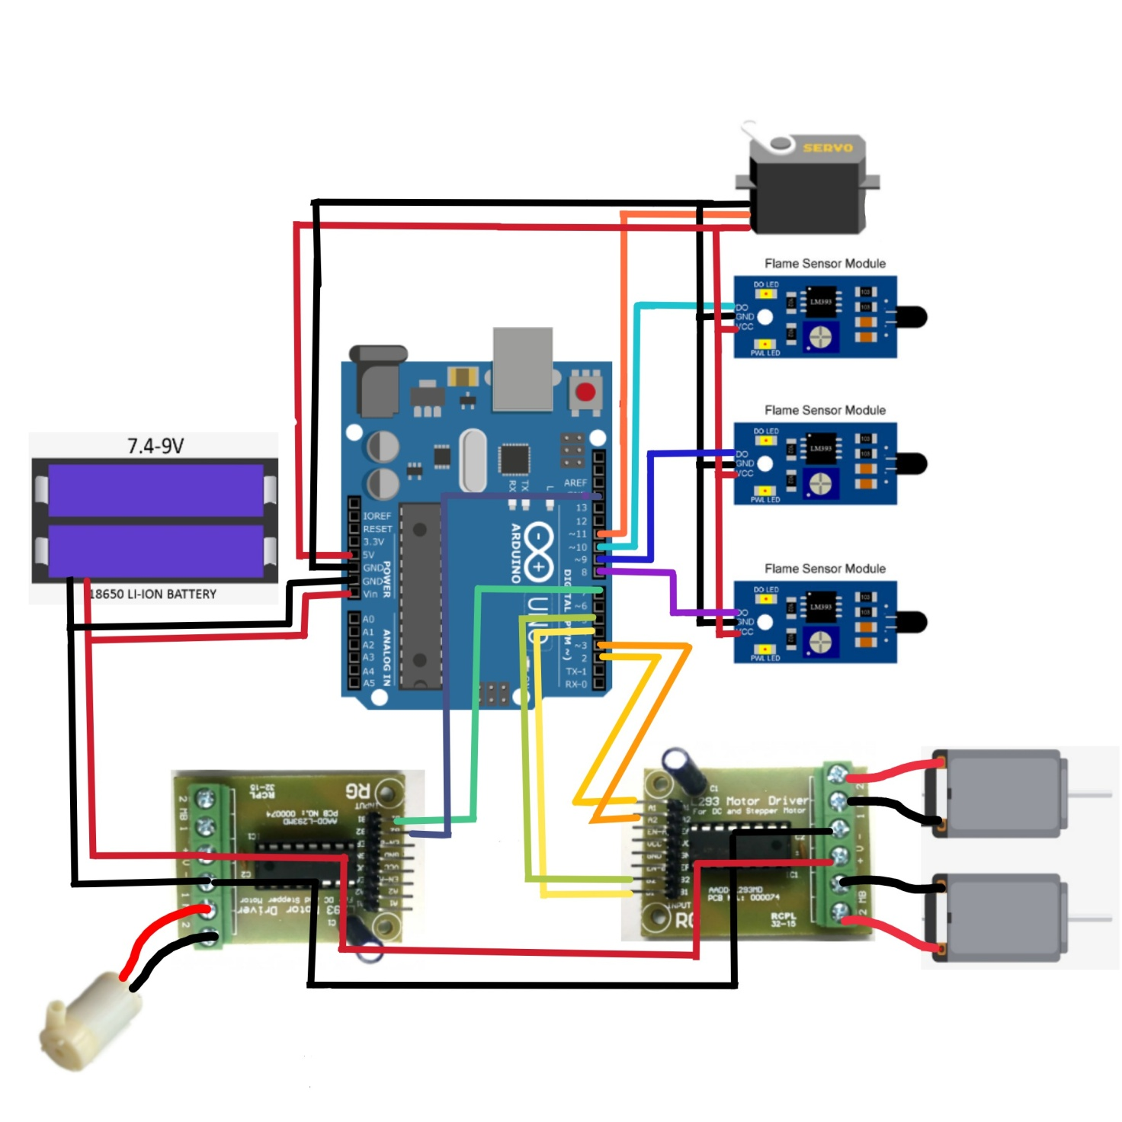

Problems

